**Cheat Sheet for Pandas**

**Difference between assign and insert method:**

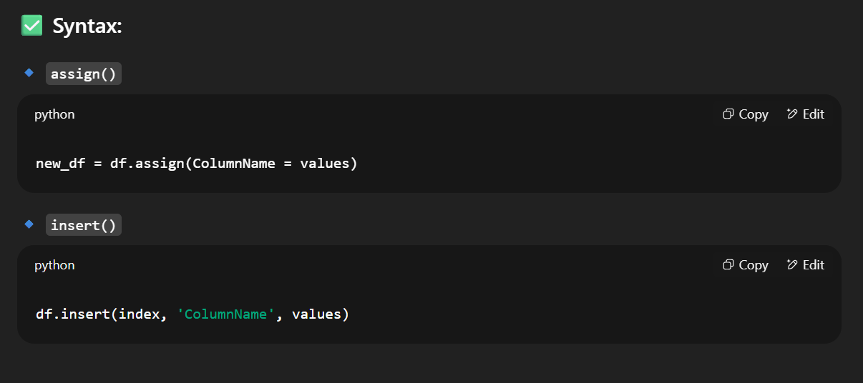

**Operations on data Frame (Column and Row wise):**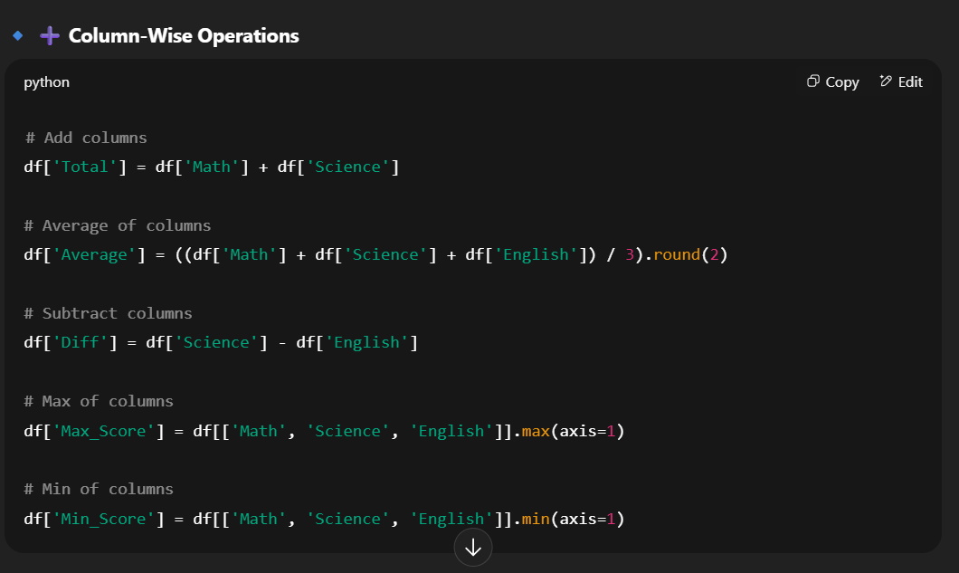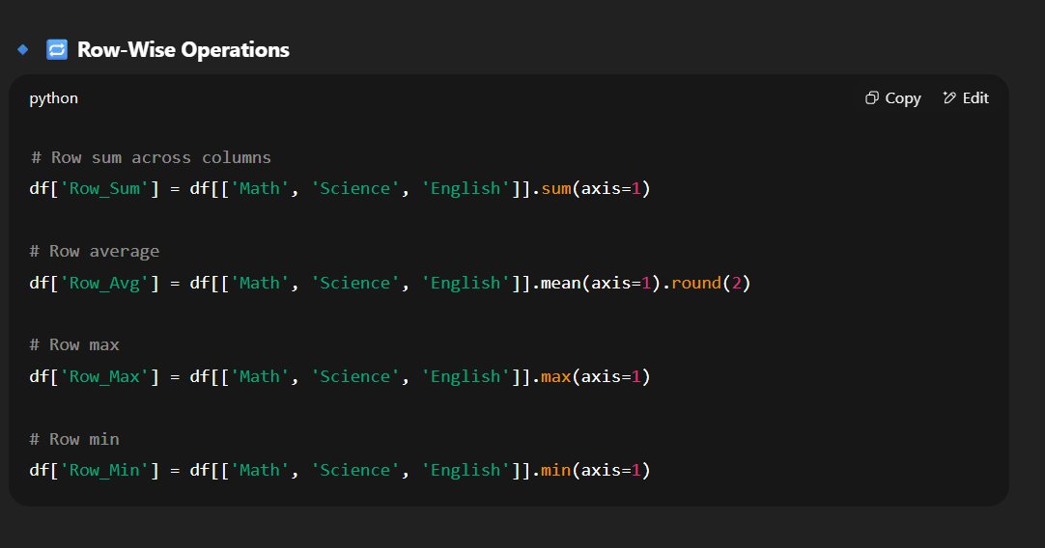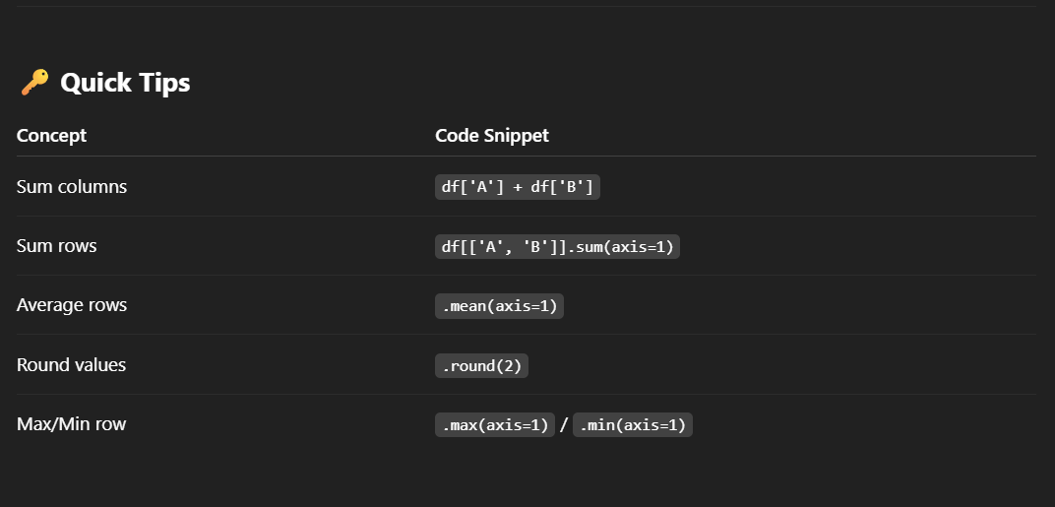

**Axis in pandas:**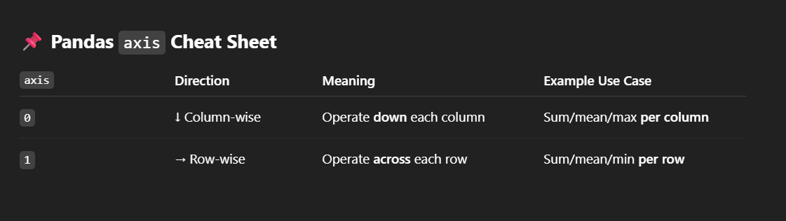

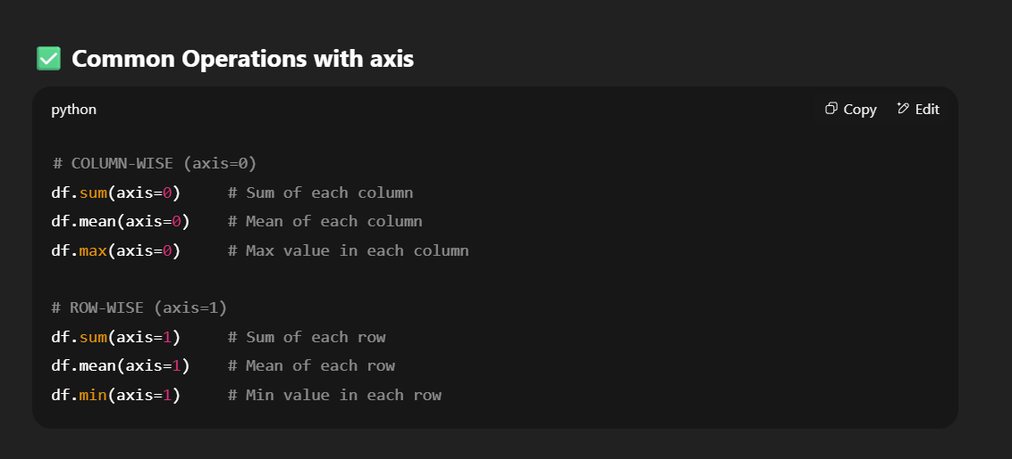

**Count values by Category in pandas:**

